# Tasks

**Objective Questions**

1. **What is the total no. of tables present in the data?**

= 2.

**2. What is the total no. of attributes present in the data?**

= 20

**3. How many categorical columns are there in the data? [Search about categorical and continuous data, and try to answer this question]**

= 15.

**4. The data consists of some inconsistent and missing values so ensure that the data used for further analysis is cleaned**.

= In the source data, I encountered inconsistency in two columns: the cuisine column had blank cells, which I rectified by removing them, and the Datekey_Opening column contained dates in a non-standard format, which I standardized using the find and replace function.

**5. Using the LookUp functions, fill up the countries in the original data using the country code**.

**=** By using VLOOKUP I fill up the countries column in the original data using the country code.

**6. Create a table to represent the number of restaurants opened in each country**.

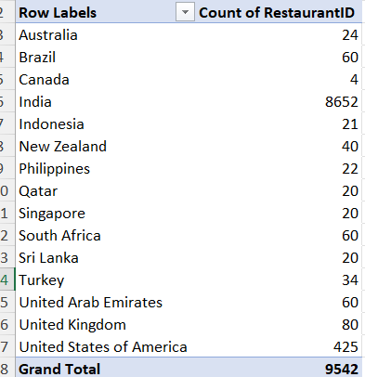

**7. Also, the management wants to look at the number of restaurants opened each year, so provide them with something here.**

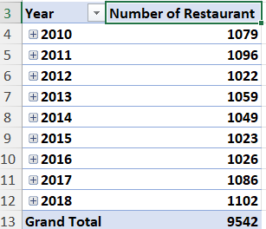

**8. What is the total number of restaurants in India in the price range of 4?**

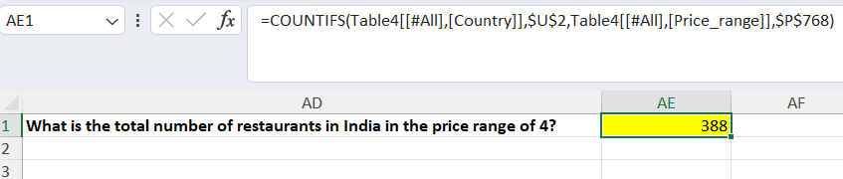

**9. What is the average number of voters for the restaurants in each country according to the data?**

**=** 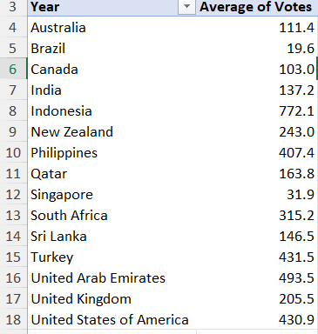

10. **Calculate the average rating for all the restaurants that have price_range < 4 and provide online delivery. Use only the “IF” function, Logical Operators, and Aggregation functions to solve this problem. [Note: Don’t use Conditional aggregation in this question.]**

= 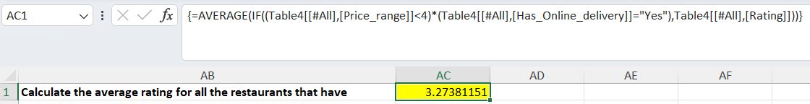

**11. Using Conditional formatting highlight the rows of restaurants that are located in the countries or cities that you’ve suggested to the management for opening new restaurants** .  **=** HOME -> Conditional formatting -> New Rule -> Use a formula to determine which cell to format

=AND($M2=$M$3,$P2=3,$S2>2.8,OR($R2>250,$R2<500)

**12. Create a new customized price column that consists of the abbreviation/symbol of the currency along with the Average_cost_for_two value. [Use string operations to do this task]**

**=** =MID($K2,FIND("(",$K2)+1,FIND(")",$K2)-FIND("(",$K2)-1)&R2

formula extracts text within parentheses from cell K2 and then appends the content of cell R2 to it. It does this by finding the positions of the opening and closing parentheses in cell K2, calculating the length of the text inside the parentheses, and then using the MID function to extract that text. Finally, it concatenates this extracted text with the content of cell R2.

.

**13. How can you create an array formula in Excel or Google Sheets to count the number of restaurants listed that do not offer online delivery, are in the lowest price range, and have an average cost for two people less than or equal to 250 Indian Rupees?**

**=** 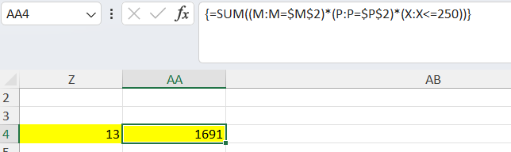

**SUBJECTIVE QUESTION**

1. **Suggest a few countries where the team can open newer restaurants with lesser competition. Which visualization/technique will you use here to justify the suggestions?**

**=** In considering where to launch Zomato restaurants, I believe we should target countries to open restaurant with the average price for two at a restaurant is affordable. So I look for countries where restaurant ratings are lower and the price range is higher.Constraints I use is averagecost of two (>1500) and rating (< 4). So the countries are **Australia ,Brazil,Canada,Singapore.**

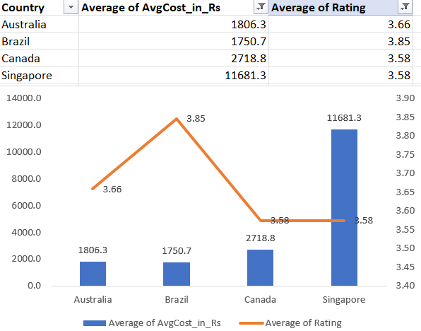

1. **Come up with the names of States and cities in the suggested countries suitable for opening restaurants.**

**= Following my previous suggestion of** New Zealand, Philippines, Qatar, Singapore based on their lower rating and average price of two >1500. **I would again prioritize cities with a lower rating of restaurants(<4) and high average price of two(> Rs.1500) within these suggested countries for Zomato's new restaurant opening Cities are in table.**

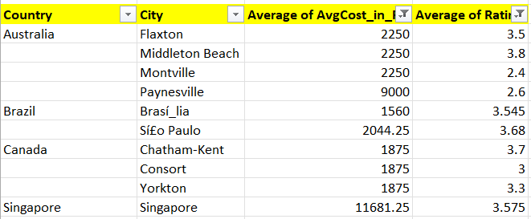

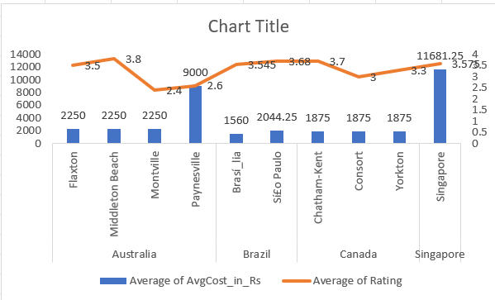

1. **According to the countries you suggested, what is the current quality regarding ratings for restaurants that are open there?**

**=** To assess current quality based on ratings, I calculated the average rating for restaurants in each country. According to the summary, Australia has avg.rating 3.7,Brazil has 3.8, Canada has 3.6 and Singapore 3.6 .

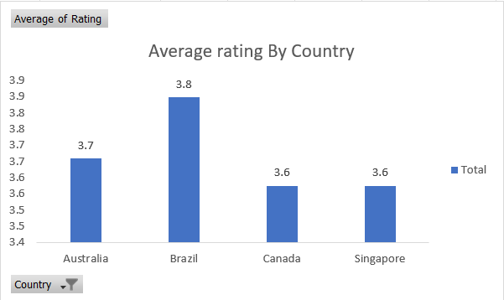

1. **Also, what is the current expenditure on food in the suggested countries, so we can keep our financial expenditure in control?**

**=** To address the question about current expenditure on food, I calculated an average based on the cost for two diners (presumably an average meal cost). Based on the information I found, the average cost for two in Canada is approximately Rs. 2,718, while Brazil is Rs. 1750 ,Singapore is Rs. 11681.

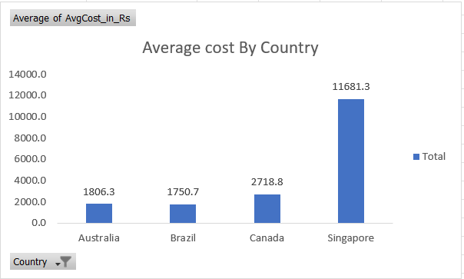

1. **Come up with the names of restaurants from the recommended states that are our biggest competitors and also those that are rated in the lower brackets, i.e. 1-2 or 2-3.**

**=** I initially created separate charts for each country because the voting ranges differed significantly between them.The number of votes by each restaurant name, filtering those with set a minimum threshold: 150 votes for Canada, 150 votes for Australia, and 29 votes for Singapore. The resulting list of restaurants was then organized into groups based on their rating ranges. Essentially, it involved counting votes for each restaurant and categorizing them by their rating level, in their particular countryand considering only those with a significant number of votes.

**Australia**

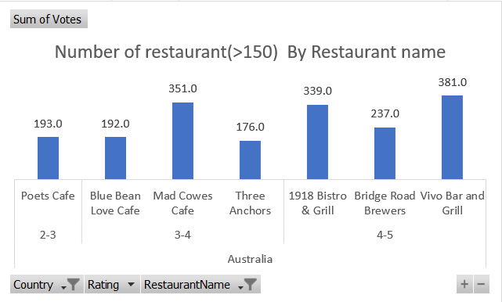

Brazil

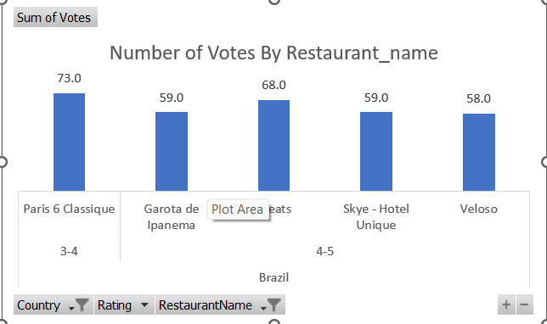

**Canada**

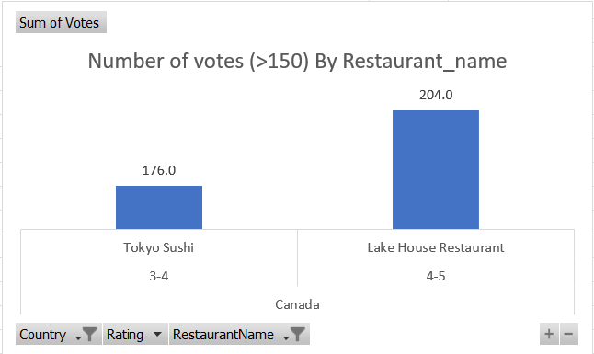

**Singapore**

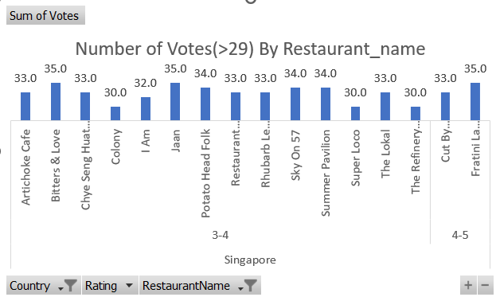

1. **Which cuisines should we focus on in the newer restaurants to get better feedback? Does the choice of cuisines affect the restaurant ratings?**

**=** I began by creating a pivot chart that visualizes the relationship between restaurant ratings and the number of votes

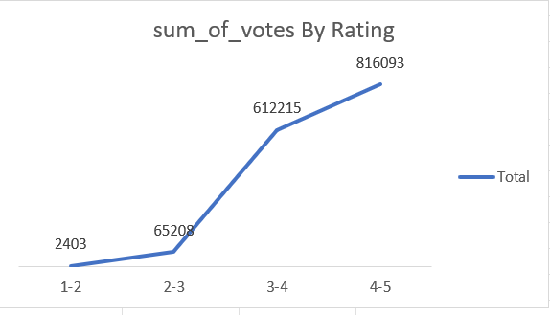

After reviewing the chart, it's evident that ratings between 4 and 5 received the highest number of votes. Consequently, I've concluded that focusing on cuisines associated with this rating range would be optimal

After analyzing the chart and applying the condition that the number of votes should be maximum, I determined the cuisine associated with the highest-rated range, between 4 and 5, to be the optimal choice for improving cuisine quality.

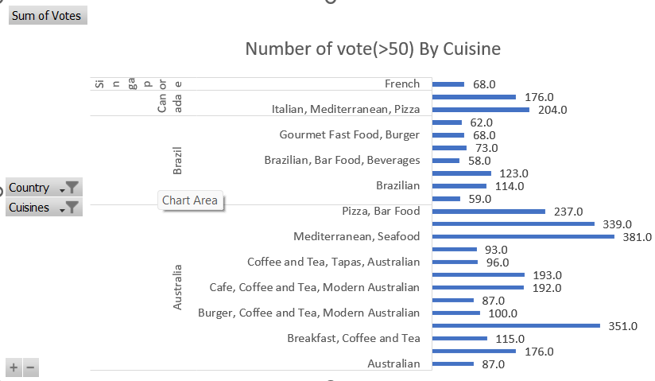

We should prioritize focusing on the cuisines highlighted in the chart, as they consistently receive high votes along with favorable ratings

Yes, the choice of cuisines does affect restaurant ratings, as indicated by the correlation between high votes and favorable ratings for certain cuisines highlighted in the chart.

1. **According to our current data, should we go for online delivery and table booking? Does that affect the customer’s ratings?**

**=** I created a chart comparing the count of online delivery orders to the average voting score. From this chart, it became apparent that restaurants with online delivery services, despite being fewer in number, tended to have higher average ratings compared to those without such facilities

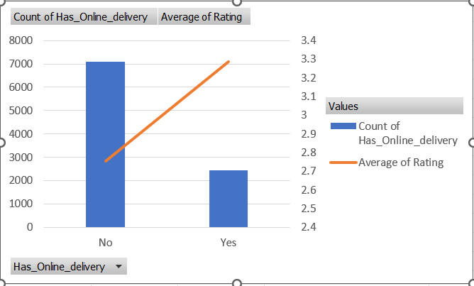

Same reason for table booking also.

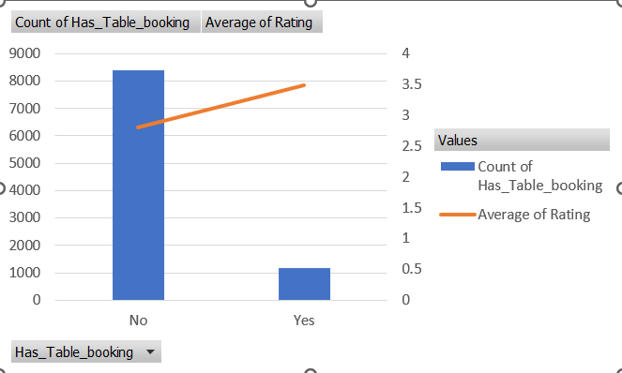

Yes, it appears that the presence of online delivery services may positively influence customer ratings, as indicated by the higher average ratings observed for restaurants offering this facility compared to those without it.

1. **Should the team keep the rate of cuisines higher? Will that affect the feedback? According to our data are the rates of cuisines and ratings, correlated?**

**=** With a correlation coefficient chart it suggests there is a very weak positive correlation between the rates of cuisines and ratings. This means that while there might be a slight tendency for higher cuisine rates to be associated with higher ratings, the relationship is almost negligible. Therefore, based on this correlation factor alone, it may not be advisable for the team to solely focus on keeping the rate of cuisines higher to expect a significant impact on feedback

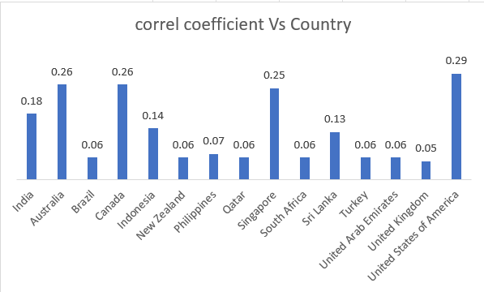

1. **What is the distribution of the number of restaurants of different price ranges in all the countries?**

**=** Countries like Qatar, Singapore, and South Africa seem to have a larger customer base favoring restaurants in a higher price range category . This suggests a potential market for upscale or premium dining establishments in these locations.

* Canada, Australia, and the United States appear to have a higher concentration of customers frequenting restaurants in the mid-range price bracket (represented by number 2). This indicates a potential demand for casual dining or restaurants offering good value for money
* India stands out as a country where customers seem to gravitate more towards budget-friendly restaurants (represented by number 1). This suggests a market where affordability might be a key consideration for diners.

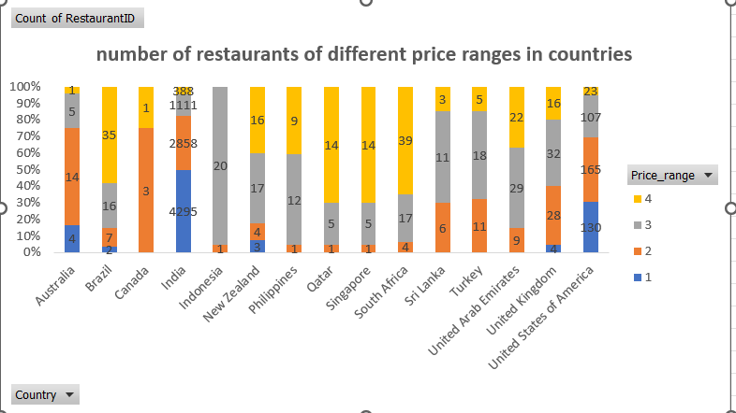

1. **Explain your approach in brief for suggesting countries/cities in order to open new restaurants, if the objective and subjective questions would have not been given to assist you. [you have to give bullet pointers in order to answer this question]**

**=** In my opinion, it would be beneficial to include population density as an additional attribute in the source data. This information could provide valuable insights

**\***Analyzing the population density vs number of restaurant.

**\*** Target trending cuisine

**\*** delivery-friendly cuisine preference

**\*** Identify Unexplored Culinary option

**\*** Price range

**\*** Online delivery trend

**\*** User rating

**\*** Prioritize budget-friendly options in cost-conscious areas.